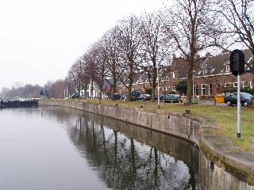
Piano as Orchestra

Monument House Concert Series
Sunday 17 December 2006
2:30 pm for 3 pm Concert

Euro 12 includes cake by InnerFireWorks.com
Keulsekade 25, Lombok, 3531JX Utrecht
tel: 030 291 0214

Reservations by e-mail: houseconcerts@pianoguitar.com
Information: http://www.pianoguitar.com/concerten/

Guitar Concerto in D Major (circa 1730) by Antonio Vivaldi (1678-1741)
Concierto de Aranjuez (1939) by Joaquin Rodrigo (1901 – 1999)
“All in Good Time” euphonium concerto (2006) by Henk Alkema (b. 1944)
Harp Concerto in C Minor (1901) by Henriette Renie (1875-1956)
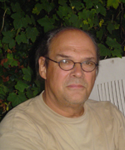
Henk Alkema composed the euphonium concerto “All in Good Time” for Harm Vuijk as a commission from the FST, to receive its orchestral debut in March 2007. Alkema’s academic appointments include professor of composition and acting dean at Utrecht Conservatory, Music Pedagogical Academy in Leeuwarden, Berklee College of Music, and the University of Montana. He has conducted nearly all professional symphony orchestras in The Netherlands and has earlier toured as a jazz pianist, composer, arranger, and studio pianist for Dutch Radio and TV. Alkema studied at the Hague Royal Conservatory of Music.

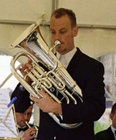
Harm Vuijk (b. 1980) was a finalist in the Euphonium Artist Competition at the International Tuba-Euphonium Conference in Budapest 2004. Active as a wind band conductor, coach, low brass teacher, brass quintet member, and euphonium soloist, he has played in the Dutch Royal Military Band and the Royal Concertgebouw Orchestra, among others. Vuijk graduated from the Utrecht Conservatory in 2004 with degrees in wind conducting, brass teaching and performance.

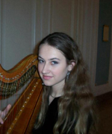
Born in Moscow in 1983, Maria Goudimov is the fourth generation of musicians. Since 2001 she has been a performing member of the Yehudi Menuhin "live music now" foundation and the first harpist of the Hamburger Jugendorchester 1999-2003. She is the first prize winner of the 1996 "Competition for young musicians of Hamburg," 1999 and 2002 German-wide "Jugend musiziert" (Youth makes music) competition, 2005 III International Vera Dulova Harp Competition in Moscow. Goudimov is currently studying under Erika Waardenburg at Utrecht Conservatory.

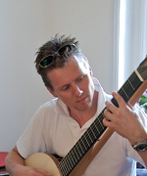
A graduate of the Conservatory of Maastricht, Robert Bekkers also studied contemporary music with Angelo Gilardino in Italy. While accompanying flamenco dance classes, Bekkers formed the group "IMPETU" consisting of 9 musicians and dancers, mixing flamenco and classical music. He has toured with Serenata Mexicana, Amstel Guitar Quartet, and Berdien Stenberg Orchestra. Since 2001, he and pianist Anne Ku have taken their Piano Guitar Duo to London, North Cyprus, Cape Town, Italy, and throughout the Netherlands. Bekkers plays a 2005 Jeroen Hilhorst concert guitar, custom-made for the duo.

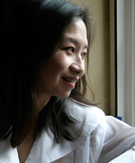
Born in Brunei of Chinese parents, Anne Ku studied piano under Betsy Hermann in Okinawa and Randall Love at Duke University. She began accompanying choirs from age 12, followed soon after by wedding engagements as pianist and organist. A graduate of London Business School, she brings her passion for thematic house concerts from Houston and London to the Netherlands. Ku is currently midway through her composition studies at Utrecht Conservatory while actively expanding her private piano teaching practice.

About Monument House Concert Series:
The recently renovated monument house at Keulsekade 25, Utrecht, near “Utrecht Centraal” station, was built by the Dutch National Water Board for its employees in 1903. With a breathtaking view of the peaceful canal between Lombok and Oog in Al, the three-storey house offers a restored Steinway Grand Piano (188 cm, model A New York 1909) and excellent acoustics with its high ceilings and centrally-heated oak floors, as demonstrated by a guitar violin duo house concert, guitar masterclass, and a showcase of violin, viola, cello, harp, piano, and voice in Summer 2006. Since then, numerous musicians from the Netherlands and abroad have enquired about performing and recording here. Collaborators and sponsors are sought for future concerts. Smoking is prohibited.

