Monument House Concert Series
Saturday 3 October 2009 SOLD OUT!
Extra concert: Thursday 1st October
Doors open 19:30 Concert begins 20:00

South African Guitarist Derek Gripper plays
"an open-minded fusion of classical and indigenous”

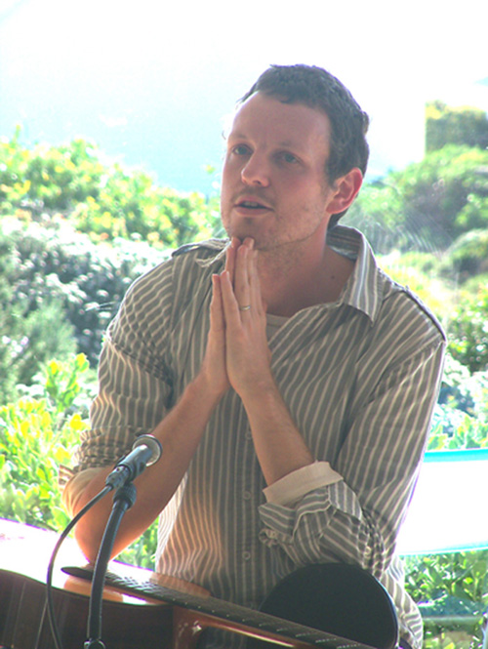
May we entice you to an evening with classical guitarist Derek Gripper on Thursday 1st October 2009? Due to popular demand, we are now holding an extra concert on Thursday 1st October in the beautiful home of our friend Merrenna nearby. Her minimalistically furnished “herenhuis” with its high ceilings and hardwood floors is ideal for such a concert.
Doors open at 19:30 with refreshments. Music begins at 20:00. South African wine and Dutch cheese will be served after the concert.
Derek’s music has been applauded as “consistently fine and immediate” [Mail and Guardian] and “a meditation coloured by interweaving tales and recollections, emotions...” [SA Rock Digest]. Grammy award winner Paul Galbraith considers him “a vital presence in the international guitar world.”
Derek has released six CDs, one of which has been nominated for a South African Geraas Award for best classical album. http://www.derekgripper.com
Anne Ku and Robert Bekkers launched the Monument House Concert Series in 2006 as a private venue to introduce art music involving either the piano or the guitar in an intimate and relaxed setting to local audiences. http://www.pianoguitar.com/concerten/

How to reserve: please e-mail merrennafrench@yahoo.com as soon as possible.

€10 for the concert and drinks, payable in cash at the door

Location: JP Coenstraat 115c 3531 ER Utrecht

Free parking anywhere in this area. Bus number 4 stops near the big church on Kanaalstraat. Nine other buses stop on Vleutensweg nearby. It’s a short walk from Utrecht Centraal Station from the west-side exit at Beatrix Theatre/Jaarbeurs going north to and turning left on Kanaalstraat.The house is located on the right (east) side of JP Coenstraat, north of Kanaalstraat but south of Vleutensweg in Lombok.

Telephone: 0657493694
E-mail: merrennafrench@yahoo.com

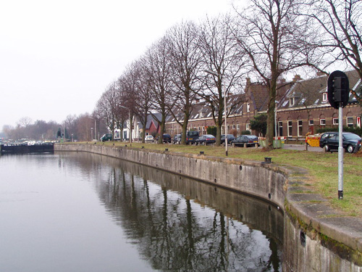
Please feel free to pass this to others who might be interested. We invite you to stay after the concert and enjoy the South African wines provided by Van Wageningen en de Lange of Utrecht. Our own-designed Monument House Glass Beer Mugs will be on sale to support the concert series. Derek’s CDs will be on sale.

Warm regards, Anne & Robert, 23 Sept 2009

STOP PRESS:

On Friday 2 October 2009 Derek Gripper is also giving master classes for Robert Bekkers’ students, followed by an 8 pm solo concert in the new building of Pier K Music School in Nieuw Vennep. Please contact us for information at info@pianoguitar.com or just show up. €10 for the concert at the door. Check http://www.pier-k.nl for route map and directions.

