Monument House Concert Series
Saturday 3 October 2009
Autumn Concert

South African Guitarist Derek Gripper plays
"an open-minded fusion of classical and indigenous”

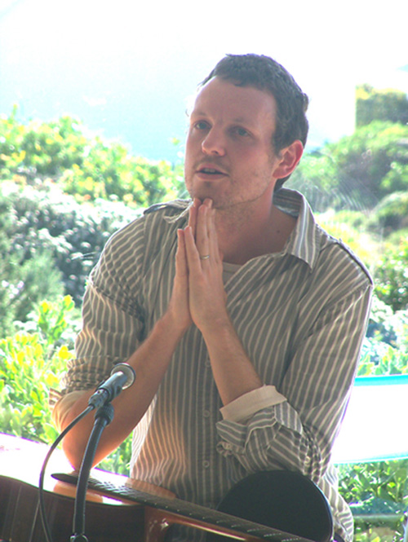
May we entice you to an evening with classical guitarist Derek Gripper on Saturday 3rd October 2009? Doors open at 19:30 with refreshments and a photo exhibition. Music begins at 20:00 with supporting acts to welcome Derek. Earlier in the afternoon, he will be giving a guitar master class and workshop. Those interested may also join him for dinner at 18:00.
Derek’s music has been applauded as “consistently fine and immediate” [Mail and Guardian] and “a meditation coloured by interweaving tales and recollections, emotions...” [SA Rock Digest]. Grammy award winner Paul Galbraith considers him “a vital presence in the international guitar world.”
Derek has released six CDs, one of which has been nominated for a South African Geraas Award for best classical album. http://www.derekgripper.com
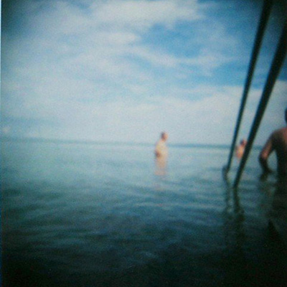
Anne Ku and Robert Bekkers launched the Monument House Concert Series in 2006 as a private venue to introduce art music involving either the piano or the guitar in an intimate and relaxed setting to local audiences. http://www.pianoguitar.com/concerten/
In the “cross domain” direction of our concert series, we invited American photographer Liz Miller will exhibit a body of work --- an untitled collection of direct polaroid images exploring water through a less perfect but ultimately more real aesthetic. Liz is a polaroid photographer and mixed-tape master who has lived, worked and taught internationally, including the US, Hungary, and Qatar, having most recently escaped from Switzerland. She has an M.F.A. from Ohio University.

How to reserve: please e-mail info@pianoguitar.com as soon as possible with your request.

Evening concert only (7:30 pm for 8 pm): €10
Vegetarian dinner at 6 pm with Derek: €10
Afternoon master class, workshop, concert: €40 participants, €25 observers

Location: Monument House Concert Series, Keulsekade 25, 3531 JX Utrecht
Free parking along the canal and surroundings. Bus number 4 stops nearby. It’s a 5 minute cycle ride or 15-20 minute walking distance from Utrecht Centraal Station. The house is near Laan van Nieuwe Guinea and Groeneweg in Lombok, opposite Oog in Al neighbourhood in Utrecht. Detailed directions available on the website: http://www.pianoguitar.com/concerten/#directions

Telephone: 030 291 0214 or 061 742 8591
E-mail: info@pianoguitar.com

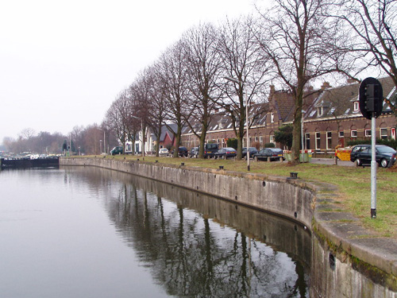
We hope you will join us on 3rd October 2009. Please feel free to pass this to others who might be interested. We invite you to stay after the concert and enjoy the South African wines provided by Van Wageningen en de Lange of Utrecht. Our own-designed Monument House Glass Beer Mugs will be on sale to support the concert series. Derek’s CDs and Liz’s works are also on sale.

Warm regards, Anne & Robert, 18 Sept 2009

STOP PRESS: On Friday 2 October 2009 Derek Gripper is also giving master classes for Robert’s students, followed by an 8 pm solo concert in the new building of Pier K Music School in Nieuw Vennep. Please contact us for information or just show up. €10 for the concert at the door. Check http://www.pier-k.nl for route map and directions.

